Database

Group number: 19

Computer Hardware store

Submission date: 12 / 07 / 2021

Team members:

1. Abdulrahman Adel Ibrahim (Section 3)

Breakdown of individual contributions

1. Abdulrahman Adel

Code:

1. Created market page displaying all products that can be categorized and a shopping cart displaying number of items in your cart.
2. Created product page with its’ corresponding product class displaying all necessary information about product and ability to add to/remove from cart.
3. Cart page with its’ corresponding shopping cart class displaying all items added to the cart with basic information about these products (name, quantity, price).
4. order page with its’ corresponding order class that the user can add the shipping information and payment details and then can confirm the order that displays a message with all information about his/her order
5. Admin page with all necessary information about admin and all his/her functionalities (Add, remove or modify a product all with their respective pages)

Database:

1. Created a Database with all necessary tables for the project (customer, admin, order, product, product list) with all of the necessary information about them

Testing

1. Created unit test for the required function to be tested in the program

1. The main purpose of the project

The purpose of this application is to provide an interactive, easy-to-use management system to allow the client of this product to purchase hardware components and to allow the owner of the store to easily customize his products and to keep record for his clients for the owner to make better decisions.

When a customer wants to buy any product of our products, he has to call us, or mail us to make sure that the product he need is available, checking its price, the available quantity, and the full description of that product.

these kinds of stuff frustrate us as we have to answer all these questions by checking our store for the availability and the too many excels sheets to check the product information.

As time goes, customers’ questions repeat itself and we have to repeat our answers and that takes a lot of time and unnecessary effort.

And unfortunately, the tragedy doesn’t end here, we also have to update our excel sheets to make it up to date for any upcoming processes after selling any product to delete it from the available products that available to customers to buy it immediately without ordering it from the trader.

Also, when we got new products, we have to add it to our excel sheets and providing all their related information like name, price, technical description.

Also, we have to ask the customer for his information like his name, phone number, and address and we have to enter this information manually by ourselves which takes lots of time and efforts, slows down our work, consumes unnecessary efforts makes us frustrated as we have to doing these boring stuffs besides the other core stuff.

Also, when we want to add new products or remove product (for many reasons like the product is sold) or edit product information like name/price/description We have to do this to manually on very large excel sheets which is very slow, and insufficient process.

When we need to add some products to our stock, we need to:

* Check what is the remaining products in stock.
* The amount of each product
* The last updated price for a specific product to set the suitable price for the new products.
* The best-selling product
* The worst-selling product

Another problem is there’re many employees, and each one of them has its information like id, name, and salary. It becomes hard process when we need to get specific information like which products added by employee with id 1 for example.

Also, we need to store customers’ data like names, addresses, and previous orders details. Also like for employees, it’s frustrating to get specific information like get the information attached only for specific customer. Like getting the purchasing history of customer whose name is Hany Mohamed for example.

Also, when it comes to ordering, we have to enter the order details manually:

Customer related Information:

order no, customer’s name, customer’s id, customer’s address, customer’s credit card number.

product(s) related Information:

Order’s no, product’s no, product’s name, product’s price, and total cost.

Sometimes specially when there’s a problem with some customer like he received a wrong product or there’s/are product(s) missing in the order, then we need to check the data we entered manually which could be entered with human mistakes to check the order’s details.

One the other side, side of employees, when there’s/are problem(s) with the products data like price, quantity, and description, or even if a product deleted from our sheets, or added with some problems, it can be very hard to figure out and discover whose fault was that.

So, because of all these problems we suggest a software application which could help us byEnables us to display our products and its full descriptionto act as a physical store but a virtual version. That’s also will eliminate the load of answering each customer’s questions and also provide customers with availability of products, their price and full technical description.

Also, not every customer has a solid technical background, so they sometimes don’t know which product is suitable for their needs, so they need to either ask for help (and we don’t want that obviously) or they can search our software for the suitable keywords and because of we will provide the full description of each product, they mission of choosing their products will become much easier.

Also, to overcome the problem of many excel sheets because we have many customers and employees, we suggest the idea of user account and admin account, and each one have its privilege.

for example, the admin profile contains his id, name, and salary. And he can add/remove/ modify products.

Also, for avoid the future possible problem like if there’s a problem with any product’s information we-the managers-need to know it’s whose fault, so we need the admin’s profile to has the products’ history of that employees to keep tracking his activity.

also, the same thing for the customer account, we suggest that customer’s account can have the past orders history that performed by this customer.

Also, we suggest adding efficient filtering criteria for the searching for orders, customers, employees and products.

Also, if there’s a way to search with more than one keyword of field like searching by name and date of order for example.

Also, we suggest that user can browse our store without having an account-to only browse- but when he going to buy a product, he must make registration, so he can feel free to browse without any feeling of commitment to anything.

2. Data (Conceptual) model

a) Domain

1.admin

|  |  |  |  |  |  |
| --- | --- | --- | --- | --- | --- |
| Column name | Data type | Length | Status | Sample | Description |
| Admin_ID | Varchar | 256 | Primary key, not null | 8c10dca2-2373-45f8-ba90-9ab3fa8a4fb | Unique number code for each admin |
| Email | Varchar | 256 | Primary key,  Not Null | [Adel.98@gamil.com](mailto:Adel.98@gamil.com) | Admin’s Email |
| Password | Varchar | 256 | Not null |  | Password for the admin’s account |
| Full_name | Varchar | 256 | Null | Fathy Ahmed | Name of the Admin |
| Salary | Double |  | Null | 1550.5 | Salary of the admin |

2. customer

|  |  |  |  |  |  |
| --- | --- | --- | --- | --- | --- |
| Column name | Data type | Length | Status | Sample | Description |
| Customer_ID | Varchar | 256 | Primary key,  not null | 8c10dca2-2373-45f8-ba90-9ab3fa8a4fb | Unique number code for each customer |
| Full_name | Varchar | 256 | Not Null | Fathy Ahmed | The first and last name of the customer |
| Email | Varchar | 256 | Primary key,  Not null | [Adel.98@gmail.com](mailto:Adel.98@gmail.com) | Customer’s email |
| Password | Varchar | 256 | Not null |  | Password for the customer’s account |
| Address | Varchar | 256 | Null | Al Amal,Faisal,Cairo | Customer’s address |
| PhoneNum | Varchar | 11 | Not null | 01181232123 | The phone number of the customer |

3. order

|  |  |  |  |  |  |
| --- | --- | --- | --- | --- | --- |
| Column name | Data type | Length | Status | Sample | Description |
| Order_ID | Varchar | 256 | Primary key,  Not null | 8c10dca2-2373-45f8-ba90-9ab3fa8a4fb | Unique number code for each Order |
| Customer_ID | Varchar | 256 | Foreign key,  not null | 8c10dca2-2373-45f8-ba90-9ab3fa8a4fb | Unique number code for the customer that placed the order |
| Full_Price | Double |  | Not Null | 2430 | The total price of the order |
| Date | Timestamp |  | Default (Current timestamp) | 11-04-2021 12:31 | The timestamp in which the order took place at |
| Product_list_ID | Varchar | 256 | Foreign key,  Not null | 8c10dca2-2373-45f8-ba90-9ab3fa8a4fb | Unique number code for the list of the product of the order |
| Shipping  Address | Varchar | 256 | Not Null | Al Amal,Faisal,Cairo | Address that the order will be shipped to |
| Payment_Method | Varchar | 256 | Not null | Cash | Either cash or credit card (with its’ info.) |
| Customer_Feedback | Text |  | Null |  | Feedback from the customer reflecting his/her experience |

4.product

|  |  |  |  |  |  |
| --- | --- | --- | --- | --- | --- |
| Column name | Data type | Length | Status | Sample | Description |
| Product_ID | Varchar | 256 | Primary key,  Not null | 8c10dca2-2373-45f8-ba90-9ab3fa8a4fb | Unique number code for each Product |
| Product_name | Varchar | 256 | Not null | Intel-i7 | Name of the product |
| Price | Double |  | Not Null | 2430 | Price of one unit of the product |
| Category | Varchar | 256 | Null | Microcontroller | Category of the product |
| Company | Varchar | 256 | Null | Intel | Manufacturing company |
| Description | Medium Text |  | Null |  | Detailed description of the product |
| Admin_ID | Varchar | 256 | Foreign key, not null | 8c10dca2-2373-45f8-ba90-9ab3fa8a4fb | The admin who added/modified the product |
| Image_Path | Varchar | 256 | Null | A:/images/cpu.jpg | The path of the image of the product in this computer |

5.product_list

|  |  |  |  |  |  |
| --- | --- | --- | --- | --- | --- |
| Column name | Data type | Length | Status | Sample | Description |
| Product_List_ID | Varchar | 256 | Primary key,  Not null | 8c10dca2-2373-45f8-ba90-9ab3fa8a4fb | Unique number code for each Product_list |
| Order_ID | Varchar | 256 | Foreign key,  Not null | 8c10dca2-2373-45f8-ba90-9ab3fa8a4fb | The order that these products belong to |
| Product_ID | Varchar | 256 | Foreign key,  Not Null | 8c10dca2-2373-45f8-ba90-9ab3fa8a4fb | Unique number code for each Product |
| Quantity | Integer |  |  | 2 | The quantity of the product |

B) E-R diagram

صورة تحتوي على نص, صحن, سوشي

تم إنشاء الوصف تلقائياً

3. Logical and Physical Modeling

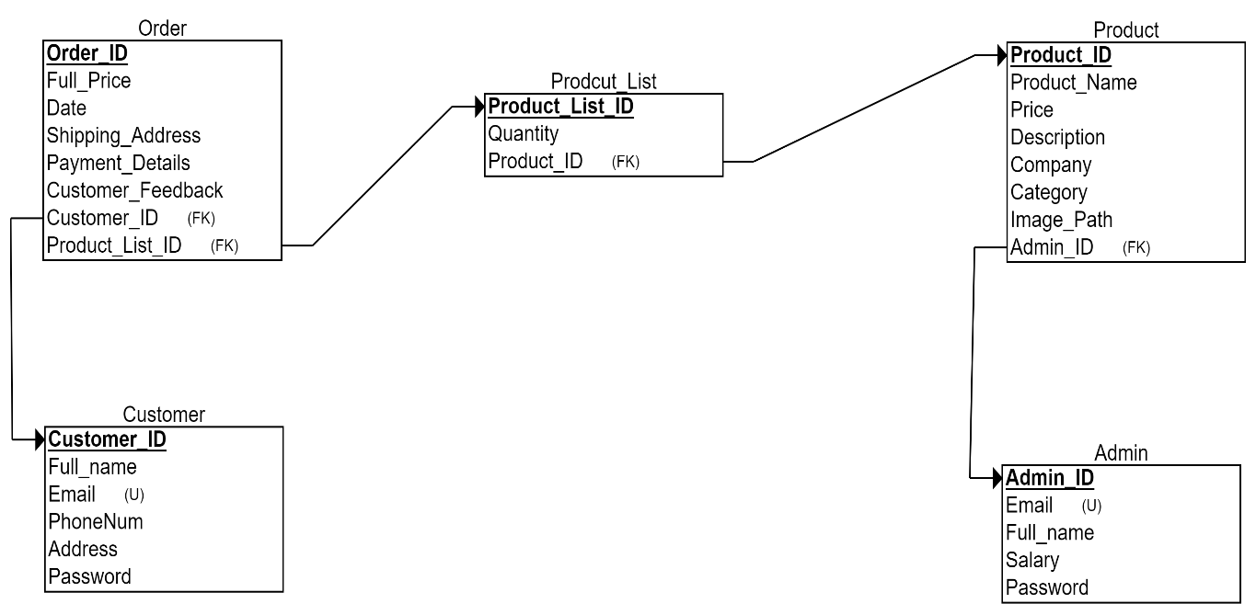

4. Database Implementation

1) Customer

Create:

CREATE TABLE Customer (  
    Customer_ID varchar(255) NOT NULL,  
    Full_name varchar(255),  
    Email varchar(255) NOT NULL,  
    Address varchar(255),  
    Password varchar(255),

Primary Key (Customer_ID, Email)  
);

Update:

INSERT INTO customer (customer_ID, Full_Name, Password, Email, Address, PhoneNum) VALUES ('"+ID+"', '"+full_name+"', '"+password+"', '"+Email+"', '"+address+"', '"+PhoneNum+"')";

2) Admin

Create:

CREATE TABLE Admin (  
    Admin_ID varchar(255) NOT NULL,  
    Full_name varchar(255),  
    Email varchar(255) NOT NULL,  
    Password varchar(255),

Salary Double,

Primary Key (Admin_ID, Email)  
);

Update:

"INSERT INTO admin (Admin_ID, Salary) VALUES ('"+ADMIN.getID()+"', 1550.0)";

"UPDATE admin SET Email = '"+Email+"', Password = '"+password+"', Full_Name = '"+full_name+"' WHERE Admin_ID = '"+ADMIN.getID()+"'";

3) Order

Create:

CREATE TABLE Admin (

    Order_ID varchar(255) NOT NULL,  
    Date varchar(255),  
    Full_Price Double NOT NULL,  
    Shipping_Address varchar(255),

Payment_Method varchar(255),

Customer_Feedback varchar(255),

Customer_ID varchar(255) NOT NULL,

Product_List_ID varchar(255) NOT NULL,

Primary Key (Order_ID),

FOREIGN KEY (Customer_ID) REFERENCES Customer (customer_ID),

FOREIGN KEY (product_list_ID) REFERENCES Prodcut_list (product_list_ID)

);

Update:

"INSERT INTO order (Order_ID, Customer_ID, Full_Price, Shipping_Address, Product_List_ID, Paymen_Method)"

+ "VALUES ('"+or.getOrder_ID()+"', '"+cS.getID()+"', "+sC.getTotal_price()+", '"+address+"', '"+sC.getID()+"', '"+payment+"')";

4) Product_List

Create:

CREATE TABLE Admin (  
    Prodcut_List_ID varchar(255) NOT NULL,  
    Product_ID varchar(255),  
    Quantity int NOT NULL,

Primary Key (Product_list_ID),

FOREIGN KEY (Product_ID) REFERENCES Product(Product_ID)  
);

Update:

"INSERT INTO product_list (Product_List_ID, Order_ID, Product_ID, Quantity)"

+ "VALUES ('"+sC.getID()+"', '"+or.getOrder_ID()+"', '"+pr.getID()+"', "+pr.getQuan()+")";

5) Product

Create:

CREATE TABLE Admin (  
     Product_ID varchar(255) NOT NULL,  
    Price Double,

Product_name varchar(255),

category varchar(255),

Company varchar(255),

Description Text,

Image_Path varchar(255),

Primary Key (Product_ID),

FOREIGN KEY (Admin_ID) REFERENCES Admin(Admin_ID)  
);

Update:

1)Delete

"DELETE FROM product WHERE Product_ID = '"+ID+"'";

2)Modify

"UPDATE product SET Product_Name = '"+product_name+"', Price = "+price+", Category = '"+category+"', "+"Company = '"+company+"', Description = '"+Description+"', Admin_ID = '"+ADMIN.getID()+"', ImagePath = '"+ImagePath+"' WHERE Product_ID = '"+ID+"'";

3)Add

"INSERT INTO product (Product_ID, Product_Name, Category, Company, ImagePath, Description, Price, Admin_ID)"+ "VALUES ('"+pr.getID()+"', '"+pr.getName()+"', '"+pr.getCat()+"', '"+pr.getCompany()+"', '"+pr.getImagePath()+"', '"+pr.getDes()+"', "+pr.getPrice()+", '"+admin.getID()+"')";